 

**Placement Empowerment Program**

***Cloud Computing and DevOps Centre***

**Set up a cloud based monitoring service :** Enable basic cloud monitoring and view metrices like CPU usage and disk I/O for your cloud VM.

Name: Subiksha R Department: AML



**Introduction**

### This document provides a comprehensive guide on enabling basic cloud monitoring for an Azure Virtual Machine (VM). Monitoring plays a critical role in ensuring the optimal performance and health of cloud resources. By enabling monitoring features, administrators can proactively track and manage resource utilization, identify issues early, and optimize performance.

### ****Overview****

Azure provides powerful monitoring tools that help users track the health and performance of cloud resources. By utilizing Azure Monitor and the Metrics feature, administrators can access real-time data on resource utilization, such as CPU percentage and disk I/O operations. Configuring alerts ensures that administrators receive notifications when specific conditions are met, allowing for faster response times to performance issues.

**Objectives**

The objective of this task is to:

* Enable basic cloud monitoring for an Azure Virtual Machine.
* View critical performance metrics such as CPU usage and Disk I/O.
* Configure alerts to monitor threshold breaches and facilitate prompt issue resolution.

**Step-by-Step procedure**

**STEP 1 : Create a Virtual Machine**

* Log in to the Azure Portal at <https://portal.azure.com>.

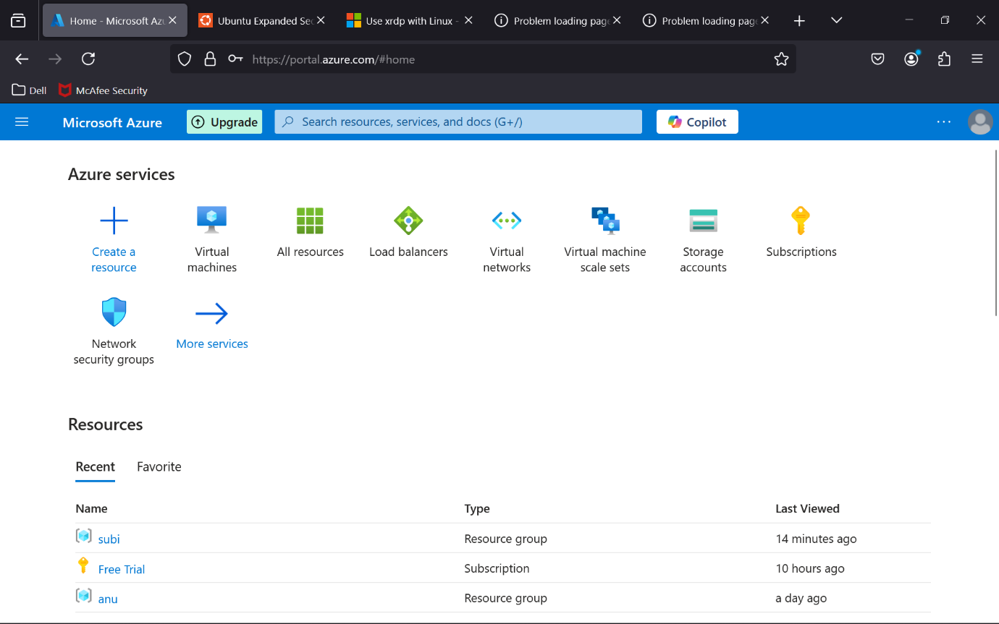

**STEP 2 :**In the left-hand menu, select Create a resource and then choose Virtual Machine.

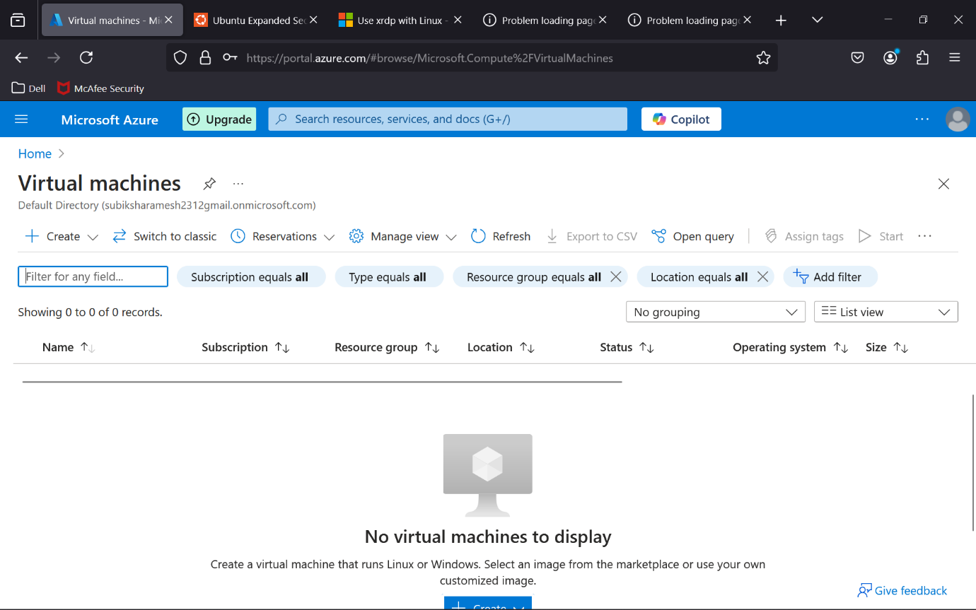

**STEP 3 :Configure the following settings**

* + Subscription: Select your Azure subscription.
  + Resource Group: Create a new resource group or select an existing one.
  + Virtual Machine Name: Provide a unique name for the VM.
  + Region: Select the appropriate region.
  + Image: Choose the desired operating system (e.g., Windows Server or Ubuntu).
  + Size: Select the VM size based on your requirements.

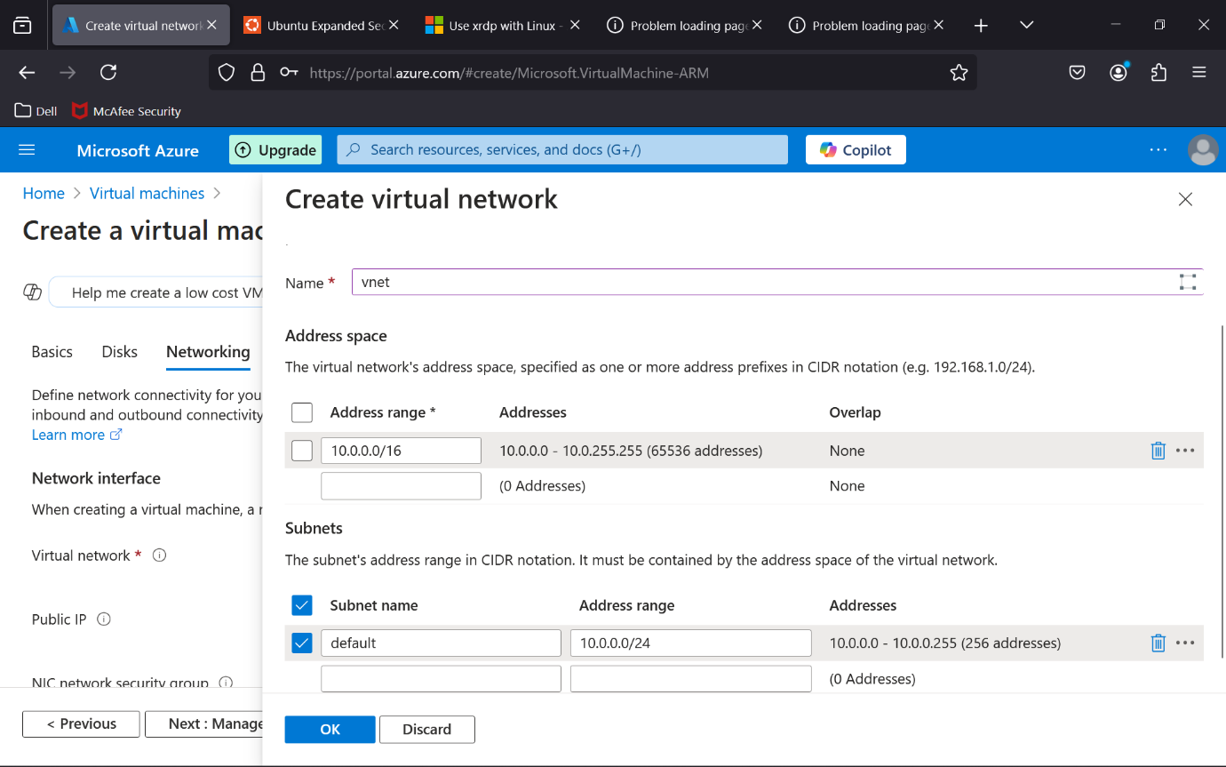

**STEP 4 :** Click Review + Create and then Create to deploy the VM**.**

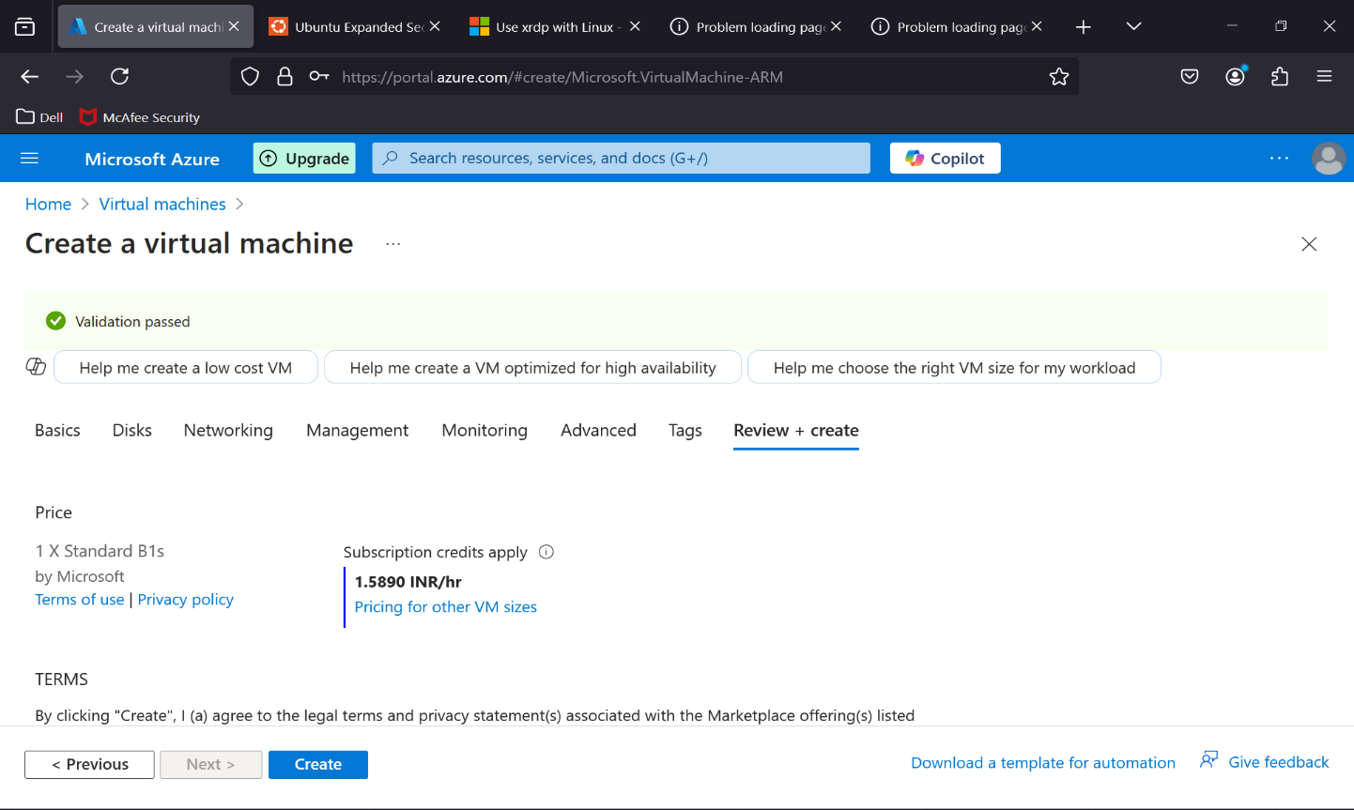

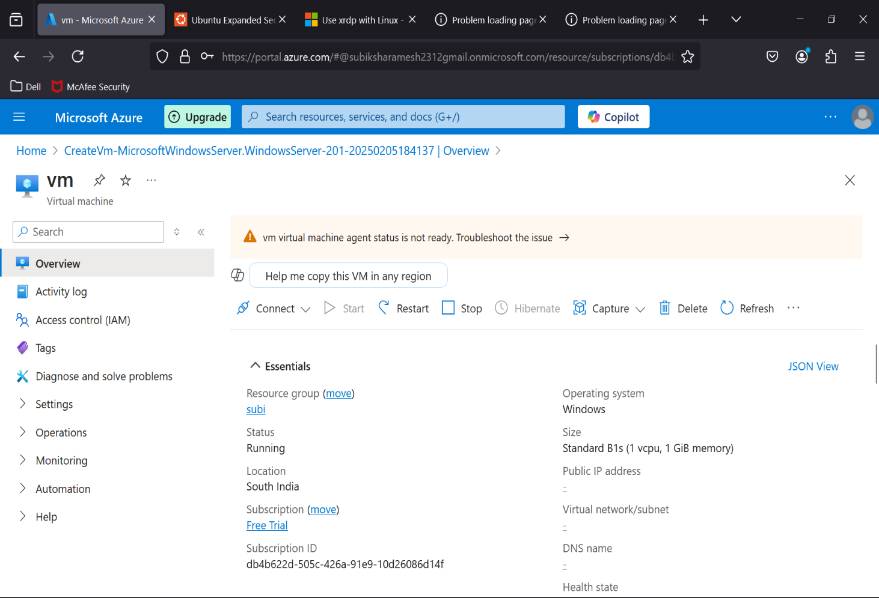

**STEP 5 :Enable Monitoring**

* Navigate to the newly created VM in the Azure Portal.
* Select Insights under the Monitoring section.
* Click Enable to activate monitoring if it’s not already enabled**.**

**STEP 6 : View CPU Usage and Disk I/O Metrics**

* Navigate back to the main VM page and select Metrics under the Monitoring section.
* Click **+ Add Metric** to create a new chart.
* Select the resource (your VM) and choose the desired metrics:
* **CPU Percentage** for tracking CPU usage.
* **Disk Read/Write Bytes** or **Disk I/O Operations** for disk metrics.
* Adjust the time range and customize the chart display as required.

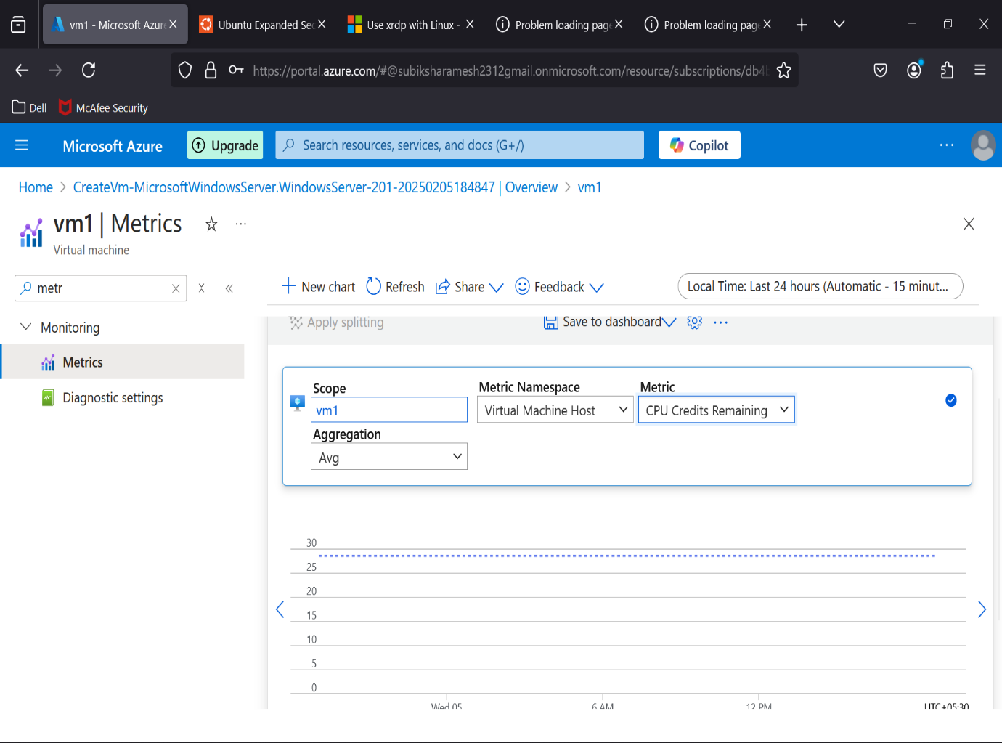

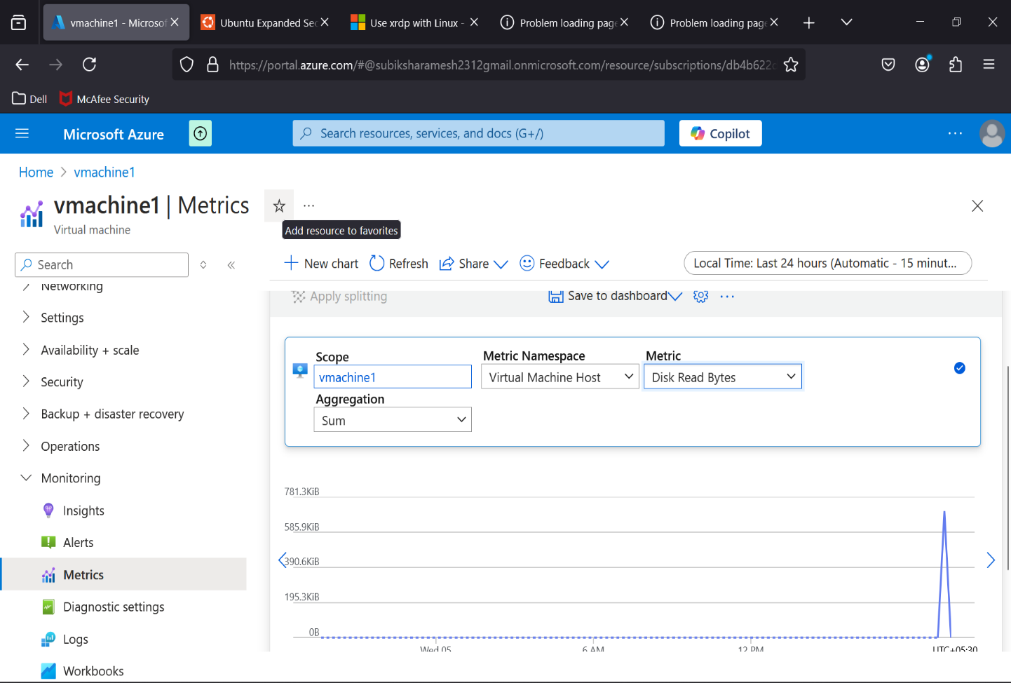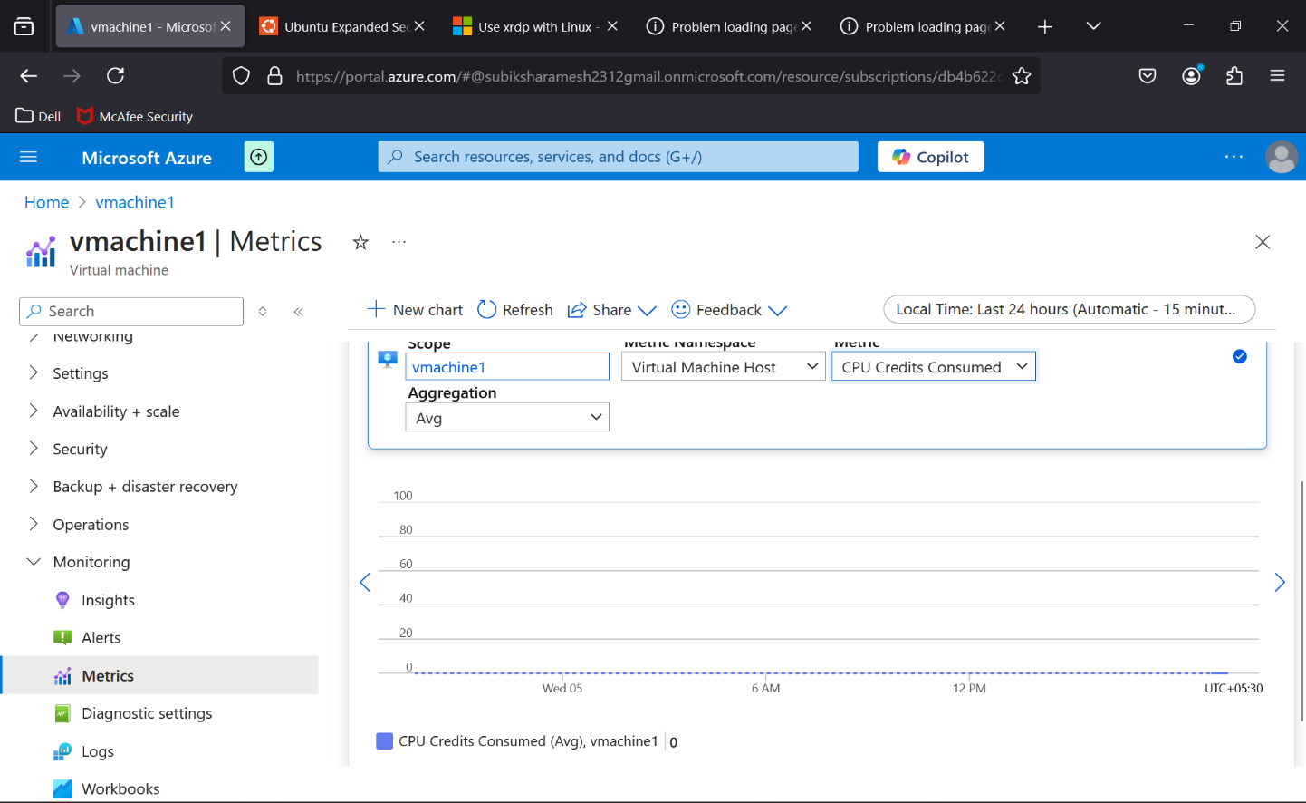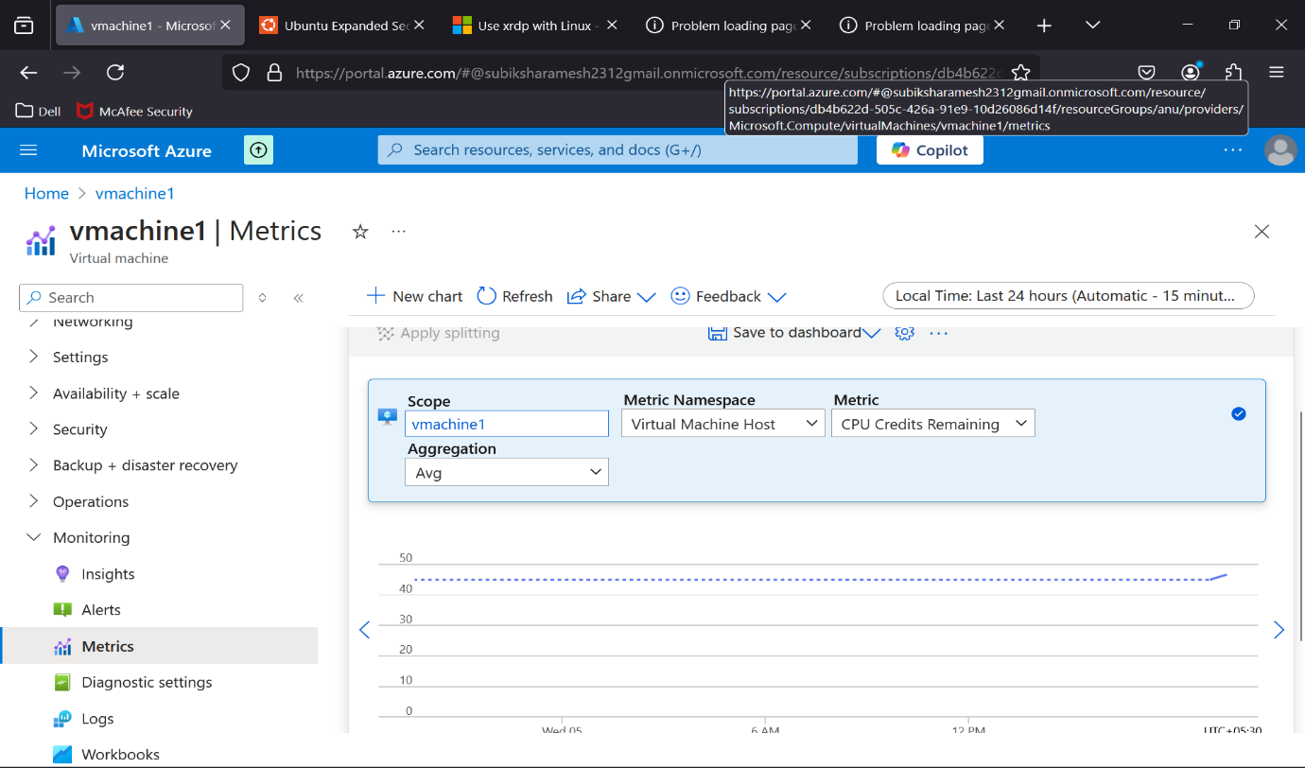

**Outcome :**

By following these steps, users will achieve the following outcomes:

* Virtual Machine Deployment: Successfully create an Azure Virtual Machine.
* Real-time Monitoring: Gain insights into key metrics such as CPU usage and disk I/O for effective resource management.
* Proactive Issue Identification: Detect and address potential performance bottlenecks before they escalate.
* Alert Configuration: Set up alerts to notify administrators when critical thresholds are reached, ensuring timely action.

This monitoring setup enables efficient resource management and improves the reliability of cloud-based applications and services.